BAYES THEOREM
Bayes' Theorem is a mathematical formula used to determine the conditional probability of an event based on prior knowledge and new evidence.
It adjusts probabilities when new information comes in and helps make better decisions in uncertain situations.
Bayes Theorem and Conditional Probability
Bayes' theorem (also known as the Bayes Rule or Bayes Law) is used to determine the conditional probability of event A when event B has already occurred.
The general statement of Bayes’ theorem is “The conditional probability of an event A, given the occurrence of another event B, is equal to the product of the probability of B, given A, and the probability of A divided by the probability of event B.”
Bayes Theorem Formula
For any two events A and B, Bayes's formula for the Bayes theorem is given by:
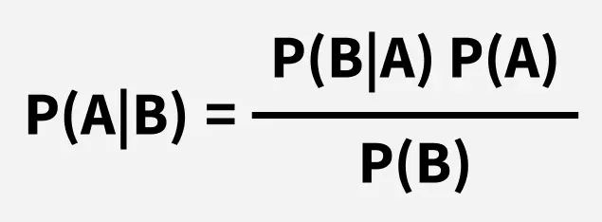
Where,
- P(A) and P(B) are the probabilities of events A and B; also, P(B) is never equal to zero.
- P(A|B) is the probability of event A when event B happens,
- P(B|A) is the probability of event B when A happens.

